**­­­**

**CHAPTER 1**

**1. INTRODUCTION**

The online doctor Appointment system in php is a simple project developed using php, HTML, and css. The project contains an admin and user sides.The admin side manage all the management like managing patient records and manage the appointment time, manage treatment facilities, Therapy packages. The admin has an important role in the management of this online doctor appointment system.

Every organization, whether big or small, has challenges to overcome and managing the information of appointment, doctor booking, doctor fees, doctor schedule. So this system help the managing patient related data,modify packages,etc.

* 1. **BACKGROUND**

Under manual doctor system,you have first wait in line to take appointment for the doctors and wait for your time to have meet with them and discuss on your health problems. As you have to provide your information and others reports such as the medicine store which is again a burden of carrying documents.and this document to be present physically at the doctor’s cabin.

In offline appointment system the patient also waits in a queue while getting appointment. If the doctor cancels the appointment for some emergency reasons then the patient is not able to know about the cancelation of the appointment unless or until he or she visits the hospital.

* 1. **OBJECTIVES**

1. Save money and save the time.
2. Used to reliable.
3. User-friendly environment.
4. Proper management of appointments and securely stores the all data.
5. A doctor appointment booking system, available on the internet, allows patients to book an appointment from the comfort of their homes, using their computer, laptop or mobile, and at any time. No matter where they are, they can contact doctors of their choice in any location.
6. The project is totally build at administrative end and thus only the administrator is guranteed the access.
7. The purpose of this system reduce the manual work.
8. To provide computer based system to overcome current paper work.
   1. **PURPOSE AND SCOPE**

**1.3.1PURPOSE**

* + - The purpose of this website is to build an website to reduce the manual work for managing the patients, appointments, Packages,products etc.
    - . As it is a web application patients can apply for appointments any time.
    - . User can track the details of his/her appointment and package details.
    - . Through the user panel patient can select the treatment packages.
    - . Reduces the admin work as well as time.
    - . The patient can upload our medical reports in appointment form.
    - . So therefore is no need to carry medical reports along with the patient.
    1. **SCOPE**

1. It will save the time and money as they need not to go to hospital or phone call.
2. Doctor can see the appointment histroy of patient.
3. User can be Update and modification of user profiles is very much easy.
4. Doctor can change or modify his time.
5. Be expandables.
6. Be easy to understand by the user and operator.
7. Reduce the cost of paper works.

**CHAPTER 2**

**SYSTEM ANALYSIS**

**2.1EXISTING SYSTEM**

1. Under manual doctor appointment system , you have to first wait in line to take appointment for the doctors and wait for your time to have meet with them and discuss on your health problem.

2. As you have your medical related information store which again load of carrying documents.

3. This documents you have prsent physically at the doctors cabin.

4. Early days doctor appointment are managed manually.

5. It required lot of time to record or retrive the details.

6. Security of information is very less.

7. You used to get information about that package only when you went to the doctor.

**2.2PROPOSED SYSTEM**

1. To make a online doctor appointment system.

2. Patients have to fill online form by which username and password created and sanded to their email and upon accepting data ,automatic login to pannel.

3. Through this website, patients select doctor and have appointment with them on their time from own place.

4. Using this system patient document upload on appointment form.

5. Esay to understand user interface.

6. Easy to use book online doctor appointment.

7. This system Gives Minimum Time requirement.

8. Ensure the data acurancy

**2.3 REQUIREMENT ANALYSIS :**

**2.3.1 Specification Of Requirement:-**

To be used efficiently, all computer software needs certain hardware components or the software resources to be present on a computer. These pre-requisites are known as (computer) system requirements and are often used as a guideline as opposed to an absolute rule. Most software defines two sets of system requirements: minimum and recommended. With increasing demand for higher processing power and resources in newer versions of software, system requirements tend to increase over time.

**2.4 HARDWARE REQUIREMENT**

**Hardware requirements (Developer side):-**

1. RAM : 4 GB

2. HARD DISK : 1 TB

**2.5 SOFTWARE REQUIREMENT**

1. OPERATING SYSTEM : Windows 10.
2. FRONT END : Visual Studio code, Bootstrap, Xamp.
3. BACK END : MySQL.
4. Browser: Google Chrome/Mozilla Firefox/Internet Explorer.

**Software Requirements (Client Side): -**

1.Browser: Google Chrome/Mozilla Firefox/Internet Explorer

2.Operating System: Windows 7 and above and Andriod , IOS

**2.6 JUSTIFICATION OF SELECTION OF TECHNOLOGY**

Selecting technologies to develpo any application is the very first step in order to come to complete an application successfully. A study of resources availability that may affect the ability to achive an acceptable system This evaluation determines whether the technology needed for the proposed system is available or not. This system can be made in any language the support good user interface and easy database handling technical needs may include.

Front-end language selection:-

Front-End means a language that is used for user interface designing and coding.

Front End should have following qualities:

* It must have go system support .
* Platform independent.
* Easy to deploy and maintain..
* Front-End must support some popular Back-End SQL Server .

According to above started feature I selected HTML,CSS as Front-End for developing my project.

Back-end language selection:-

Back-End means a language that is used for database management. Back-End should have following qualities:

* Operating System compatible.
* Easy to install.
* Various drivers must be available.
* Efficient data handling.
* Easy to implement with Front-End

According to the above stated features I selected PHP,javascript,mysql.

Javascript:JavaScript can update and change both HTML and CSS.JavaScript can calculate, manipulate and validate data. Java script is used as client side scripting language .

Php :  Hypertext Preprocessor language is widely used to use dynamic content and to manage database of website. Php is imply

PHP is a recursive acronym for "PHP: Hypertext Preprocessor".

• PHP is a server-side scripting language that is embedded in HTML. It is used to manage dynamic content, databases, session tracking, even build entire e-commerce sites.

• It is integrated with a number of popular databases, including MySQL, PostgreSQL, Oracle, Sybase, Informix, and Microsoft SQL Server.

PHP can handle forms, i.e. gather data from files, save data to a file, thru email you can send data, return data to the user.

• You add, delete, modify elements within your database thru PHP.

• Access cookies variables and set cookies.

• Using PHP, you can restrict users to access some pages of your website.

**My sql server:**

**MySQL** is a Relational Database Management System (RDBMS), named after the founder Michael Widenius ‘s daughter as “**My**” and SQL stands for “**Structured Query Language**”.

The first version of this database was released in 1995 and later on, Oracle acquired the same in Jan 2010, when it was with Sun Microsystems.

**Advantage of mysql database in xampp software**

1. **Easy to use:**As it supports SQL language, users don’t need to be technical experts to access the database. It can be easily accessed by users with basic SQL knowledge and experience with other relational databases.
2. **Cost Free:**Another benefit of using this database is that the user doesn’t have to spend money to pay the license fee, as it is free of cost and available on the official website for download.
3. **Secured:** It is highly secured.

A software process (also known as software methodology) is a set of related activities that leads to the production of the software. These activities may involve the development of the software from the scratch, or, modifying an existing system.

Here I am selecting Waterfall model as a process model for developing my project.

**Waterfall model**

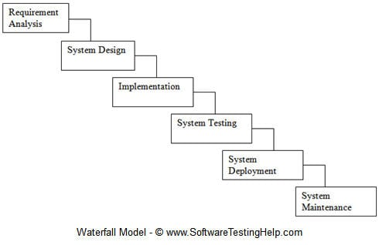

**CHAPTER 3**

**SYSTEM DESIGN**

**3.1 MODULE DIVISION**

In this system there are 8 main modules.

1. User Login

2. Home

3. Registration

4. Book appointment

5. Cancellation

6. Package Selecting

7. Admin module

**User Login**

**Patient Login**

Patient should register their details, then they can login.

**Admin Login**

Admin can login through username and password.

**Home Modules**

1. About site- Provides information about the site.
2. Doctor detail- provides information about the doctor.
3. Contact Us-gives their contact details.
4. Panchakarma Package- provides information about the Panchakarma Package,
5. User login – used for login.

**Registration Module**

1. Registration provides information about the user(Patient).

**Book appointment Module**

1. Used for booking appointment in easier way

**Cancellation Module**

1.It is used to cancel appointment

**Package Selecting**

1.It is used to selecting packages for Doctor apoointment.

**Admin Modules**

1. Admin can Add, Delete and Edit the patient id and information.
2. Admin can accept/Reject booking request.

**3.2 ER DIGRAMS**

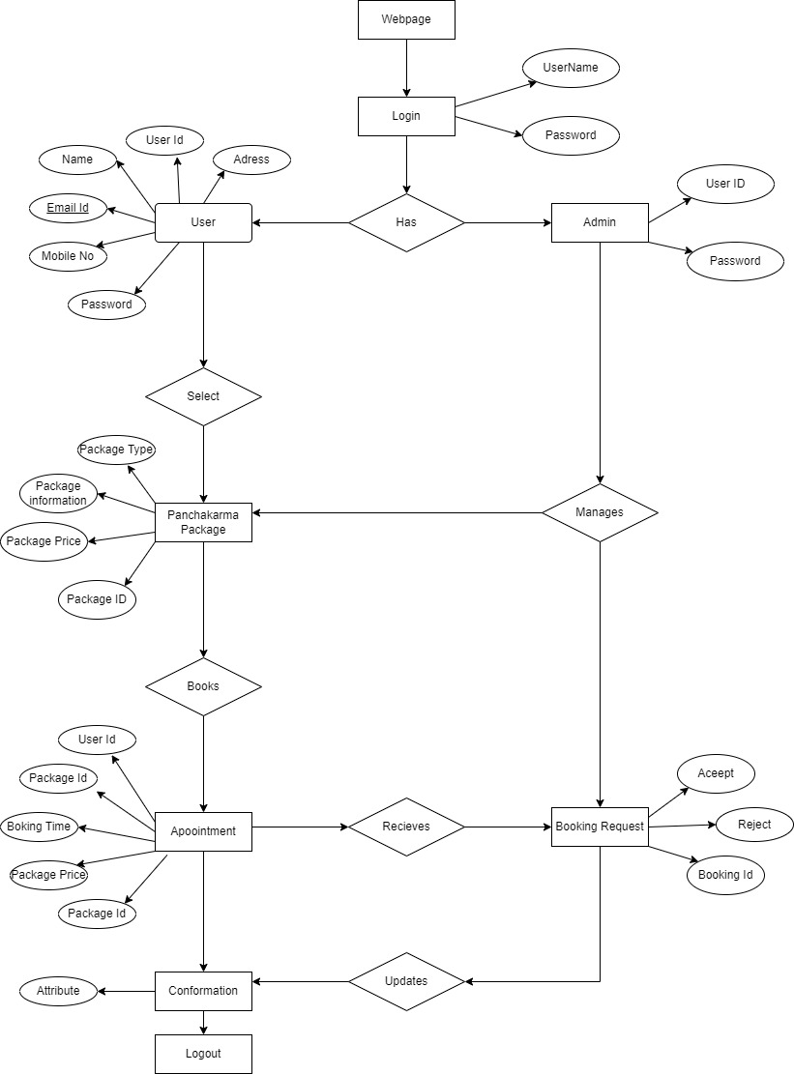

**3.3 CLASS DIGRAM**

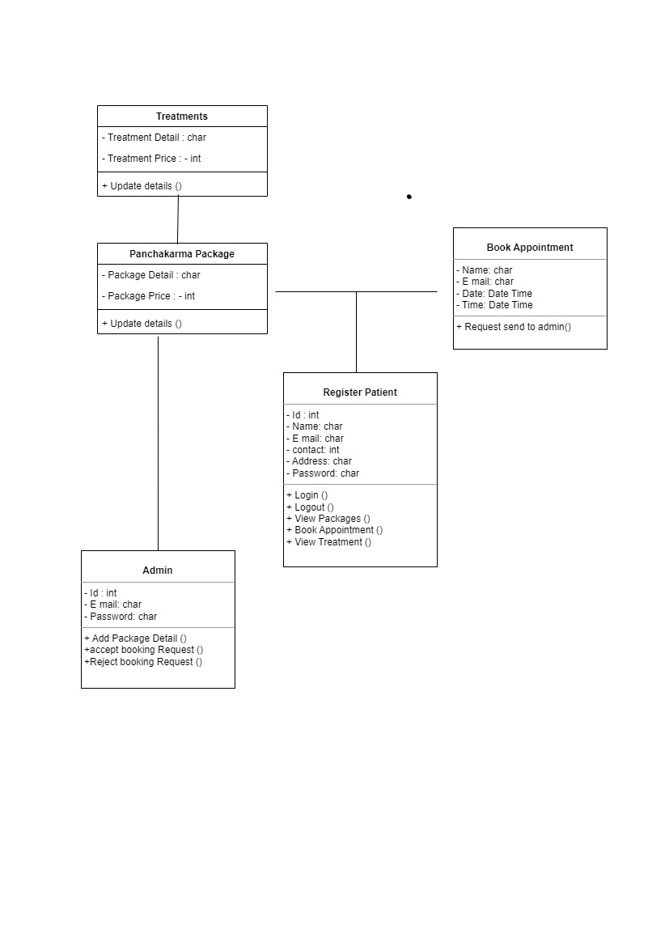

**3.4 ACTIVITY DIGRAM FOR ADMIN**

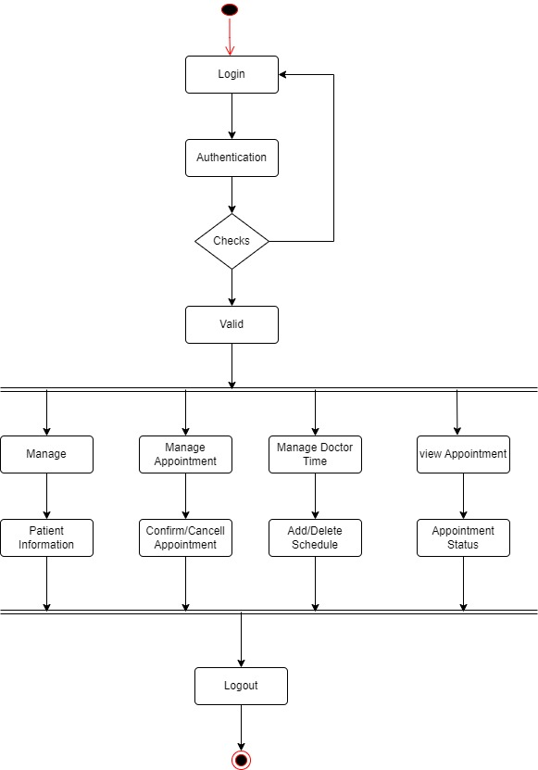

**3.5 ACTIVITY DIGRAM FOR PATIENT**

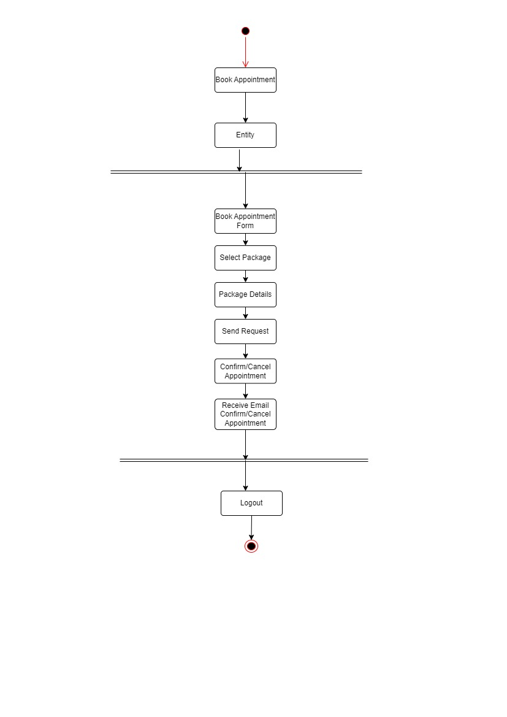

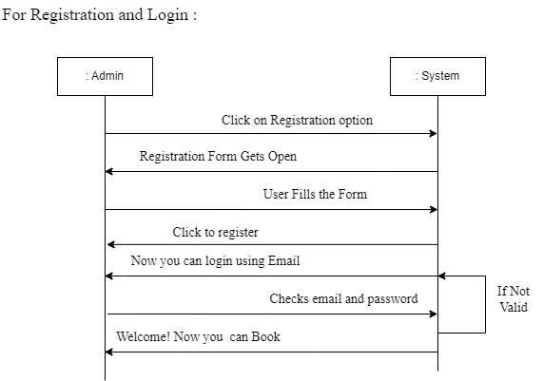**3.6 SEQUENCE DIGRAM FOR ADMIN**

**3.7 SEQUENCE DIGRAM FOR PATIENT**

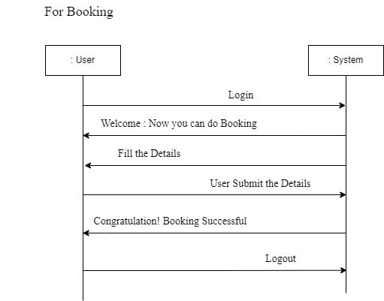

**3.7 USECASE DIGRAM:-**

**ADMIN AND PATIENT SIDE:-**

